ASSESSMENT TOOL 1

COURSE NAME: MOBILE COMPUTING
COURSE CODE: ITA03

COURSE OUTCOME COVERED

CO1: Analyse the mobile network components, mobile base station, mobile infrastructures and protocols in cellular systems. (BL-1, BL-2, BL-3)

QUESTIONS: 2 Total Marks: 100

Annexure A

Concept Mapping

Code of Conduct:

I L.M.Sharmila(192521243) (Name / Reg No) certify that this submission is my original work and that I have adhered to the guidelines specified for this assessment.

I understand that any violation of academic integrity rules will result in disciplinary action.

Signature of the student:
L.M.Sharmila

Annexure A - QUESTIONS

- Construct a concept map that evaluates the contribution of Mobile Station, Base Station Subsystem, and Network Switching Subsystem toward seamless communication.
Illustrate their interdependencies.
Assess which subsystem has the greatest influence on service continuity.
Justify your conclusions using concept relationships.

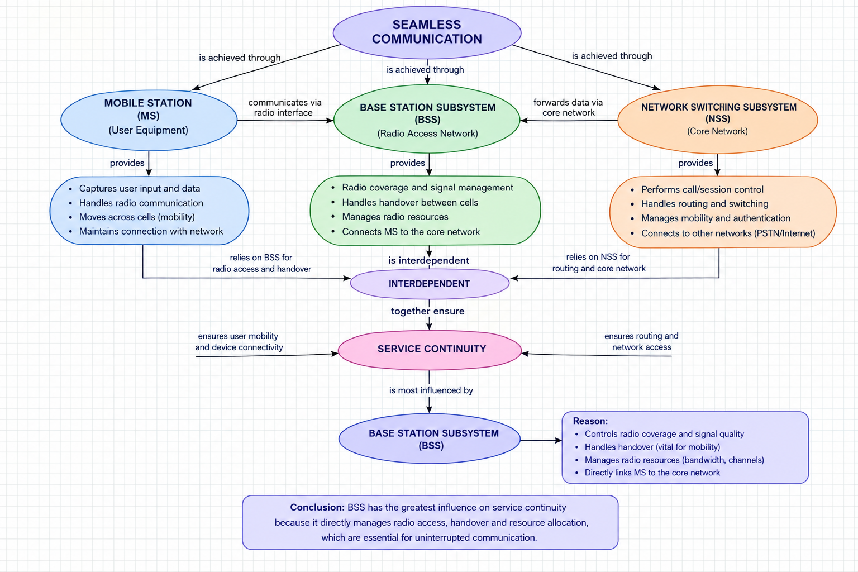

- Develop a concept map that evaluates the effectiveness of the mobile network protocol stack.
Illustrate interactions among protocol layers.
Assess how each layer contributes to reliable mobile communication.
Support your evaluation with meaningful hierarchical relationships.

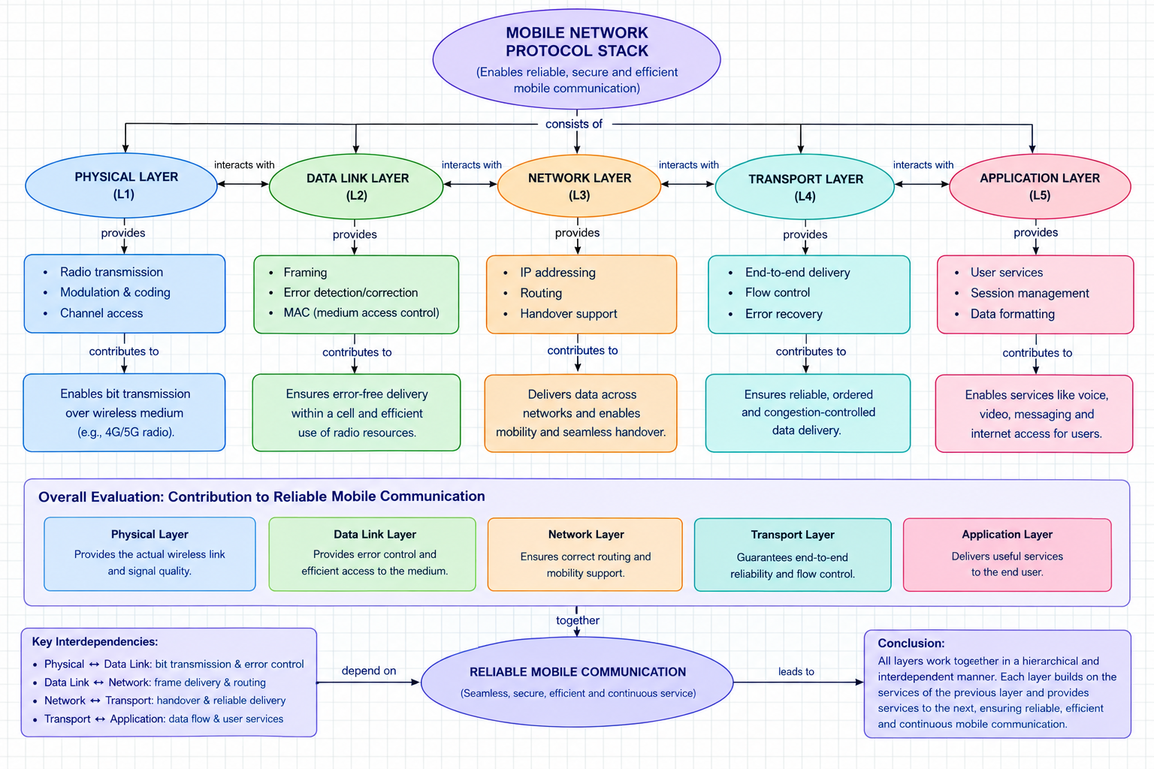

Rubrics for Calculation

Criteria | Weightage | Level 4 – Exemplary | Level 3 – Proficient | Level 2 – Developing | Level 1 – Beginning
Understanding of Problem Context | 20% | Clearly understands the problem and accurately identifies all requirements | Good understanding with minor gaps | Basic understanding; some requirements unclear | Poor understanding or misinterpretation of the problem
Application of Concepts | 30% | Accurately applies appropriate concepts to solve complex problems | Applies relevant concepts correctly with minor errors | Applies basic concepts with limited accuracy | Fails to apply appropriate concepts
Problem-Solving Approach | 20% | Logical, well-structured, and efficient approach | Mostly logical approach with minor gaps | Basic approach with some inconsistencies | Illogical or unclear approach
Accuracy of Solution | 20% | Completely correct solution with proper justification | Mostly correct with minor errors | Partially correct solution | Incorrect or incomplete solution
Clarity | 10% | Clear, well-organized, and properly explained solution | Understandable with minor clarity issues | Limited clarity and explanation | Poorly presented and difficult to understand

